1. 
2. We need to deploy our app on different environments such as Dev, QA, UAT, PROD etc.
3. Spring provides profile concept for this.
4. 
5. 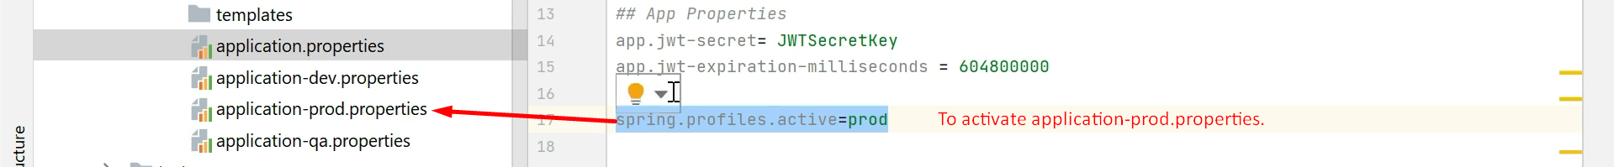
6. Text

   Description automatically generated